

2023

**Ali Baloch, Student ID#501214761**

**11/25/2023**

AI Solutions with Machine Learning for Wildfire Containment in Canada

Final Results: Table of Contents

1. [Definition of problem](#Defineproblem) & objectives
2. Data [Preparation](#DataPreparation)
3. [Model](#ModelSelectionBuilding) [Selection](#ModelSelectionBuilding) & Building
4. [Model Evaluation](#ModelEvaluation)
5. [Interpretation & explanation](#Interpretationandexplanation)
6. [Limitations & Future Directions](#Limitations_FutureDirections)

[Dataset and Data Description & links](#Datasetusedforfinal)

[References and current state of affairs](#REFERENCES)

**Fort McMurray, Alberta disaster of 2018 costing around $9 billion, the most expensive in Canadian history**

**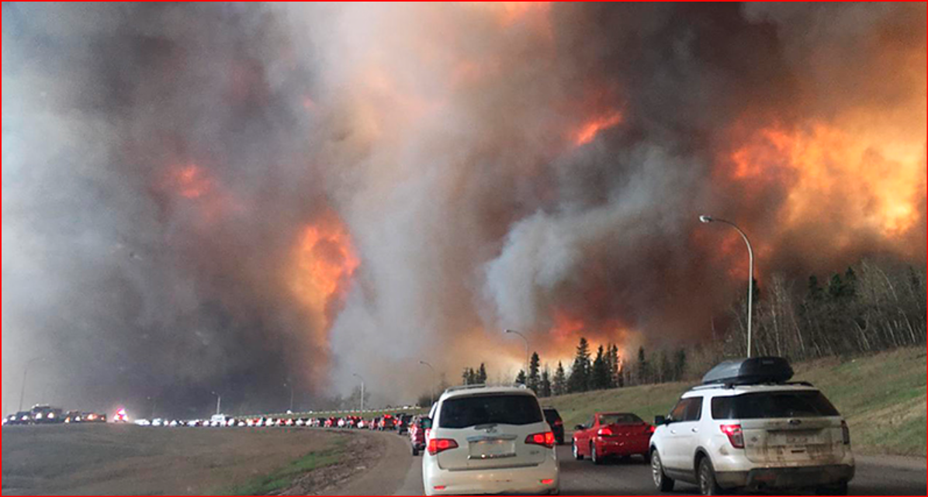**

**1 Define the Problem and Objectives**:

“Fire is a multifaceted issue that needs a multipronged approach,” he said. “There’s no silver bullet or vaccine that’s going to make this thing go away. We really do have to learn to live with fire.” Earlier in 2023, Mike Flannigan, research chair for predictive services, emergency management and fire science at Thompson Rivers University in British Columbia noted that 2023 fire season was a modern-day record. He further suggested to increase imposing fire bans and closing forests to recreational and industrial users before the fire season gets on our heads (<https://www.aljazeera.com/news/2023/6/7/canadas-record-wildfires-should-be-wake-up-call-experts-warn>).

Alberta Wildfire (first in Canada) started using an Artificial Intelligence-powered (AI-powered) tool in 2022 to help duty officers allocate resources more advantageously not knowing the sheer speed and size of these wildfires or even if they would appear or not <https://news.microsoft.com/source/features/ai/ai-alberta-canada-wildfire-firefighting/>.

To gain or to attempt gaining an advantage can come with the help of AI-powered machine learning solutions combined with firefighter’s experience in gauging the different landscapes in Canada where fire can occur at a rapid speed.

***Objectives***

The first goal of this paper is to provide evidence as to how the model helps explain the relationships between variables.

The second goal is the prediction, to show that the model's predictions are accurate based on the most relevant variables.

***Main Question***

Is climate change behind the wildfire devastation? Is exploiting land for fossil fuels the primary cause of the global climate crisis? Since the end of the 19th century, weather conditions have played the most critical role and can largely be attributed to industrial revolution. This has given rise to extreme temps around the world, and have increased severe and ferocious wildfire risks. *With the help of AI machine learning, it is only a matter of time where human firefighters, satellite navigation along with AI-power tools can narrow down the most relevant weather variables in predicting areas of wildfires*.

At the end of the day, the firefighters on the ground are the ones who will extinguish the flame, not only above the ground but underground as well – how can the AI machine learning deliver against this fight?

**2** **Data Preparation:**

Data in CSV format was downloaded, sourced and combined from several government and public websites:-

1. <https://cwfis.cfs.nrcan.gc.ca/downloads/hotspots/> (csv format for 2023 & older)
2. <https://firms.modaps.eosdis.nasa.gov/download/>
3. <https://www.visualcrossing.com/resources/documentation/weather-data/how-to-look-up-weather-by-latitude-and-longitude/>
4. <https://geospatial.alberta.ca/titan/rest/services/wildfire/weather_station_reading/MapServer/2>
5. <https://open-meteo.com/en/docs/historical-weather-api>

The dataset named “**20230807\_thousand\_records\_MODIS only2&3 combined**“ was used for the final project consisting of the following fields:-

|  |  |  |  |
| --- | --- | --- | --- |
| Column | Name | Type | Description |
| 1 | Fire\_Nofire | Integer | Fire or Nofire (dependent or predictor) |
| 2 | Latitude | Numeric | Area location1 (*irrelevant*) |
| 3 | Longitude | Numeric | Area location2 (*irrelevant*) |
| 4 | ref # | Numeric | Number of records (*irrelevant*) |
| 5 | Max of temp | Numeric | Max of temperature (independent) |
| 6 | Max of soil temp | Numeric | Max of soil\_temperature\_0\_to\_7cm (independent) |
| 7 | Max of soil moist | Numeric | Max of soil\_moisture\_0\_to\_7cm (independent) |
| 8 | Fwi | Numeric | Fire Weather Index FWI (independent) |
| 9 | Fuel | Character | Fuel or type of vegetation (independent*)* |
| 10 | Ros | Numeric | *Fire’s* Rate of spread (independent) |
| 11 | Sfc | Numeric | Spatial Fire Climatology (independent) |
| 12 | Tfc | Numeric | Total fuel consumption (independent) |
| 13 | Bfc | Numeric | Bushfire fuel consumption (independent) |
| 14 | Hfi | Integer | Head Fire Intensity (independent) |
| 15 | estarea | Numeric | Estimated Area Burned (*less relevant*) |

Data was cleaned and reviewed for duplication, checked for missing data, outliers and ensured its ‘numeric’ alignment for predictive analysis. A single character category like ‘fuel’ was removed, other fields were changed to numeric for further analytics & irrelevant fields like reference #s, locations based on longitude/latitude were excluded.

For this project, I implemented a methodology to build a dataset based on 10 relevant parameters related to the state of the landscape: max temp, max soil temp, max soil moisture, rate of spread among others based on Canadian Widlfire Management System being used around the world. After identifying the hotspot data, collected the corresponding weather data based on locations from relevant weather websites, preprocessed them and finally saved them in a dataset; which was analyzed using most known supervised data mining algorithm, Decision Trees and Cross validation technique. The simulations was run using the R code where the dataset was divided into the training and testing datasets.

Few data insights:

1 The estarea ‘burned’ area based on latitude/longitude can be similar to another location based on satellite imagery which makes this *less relevant.*

2 Fuel type characterizes the kind of dry vegetation, shrubs and trees which are very dry and burn faster whereas very few are fire resistant. This detail can be a challenging to find which shrubs/trees burn faster.

3 **Model Selection & Building**:

My choice of algorithm and evaluation methods depended on the numeric characteristics of the data and the goals identified earlier. I did experiment with a couple of algorithms first and decided on Decision Trees, Random Forest machine learning algorithms & Cross Validation technique. Some reasons why decision trees and cross-validation were utilized.

Decision trees are easy to understand and interpret. The rules generated by decision trees are intuitive and can be visualized graphically, making it easier to explain to non-technical stakeholders.

Diverse Data Types: Decision trees can handle a mix of numeric and categorical data, making them suitable for datasets with both types of variables. My dataset includes a mix of numeric and integer variables.

Assumption of relationship: Decision trees do not assume any relationship between the variables and the target/predictor variable. They can capture complex non-linear patterns in the data, which might be beneficial if the data exhibits non-linear relationships.

Feature Importance: Decision trees provide feature importance scores, allowing you to identify which features are most influential in making predictions. This can be valuable for understanding the factors contributing to fire occurrence in your dataset.

Handling Imbalanced Classes: Decision trees can handle imbalanced class distributions, which is often the case in binary classification problems. If your dataset has imbalanced classes (e.g., more instances of "no fire" than "fire"), decision trees can handle this scenario.

No Need for Feature Scaling: Decision trees are not sensitive to the scale of input features, so you don't need to perform feature scaling (e.g., normalization or standardization) on your numeric variables.

Cross-Validation for Model Evaluation:

Cross-validation (CV) technique assesses the performance of the model on different subsets (with the number of independent variables 3 vs 5 vs 10) of the dataset. It provides a more robust estimate of the model's performance, reducing the risk of overfitting to a specific training set. CV is used to assess how well a predictive model will generalize to an independent dataset. It involves partitioning the dataset into multiple subsets, training the model on some of them, and evaluating it on the remaining ‘test’ subset.

Random Forest algorithm and cross validation:

Random Forest operates by constructing a multitude of *decision trees* & merges them together to get a more accurate and stable prediction. In the random forest algorithm confusion matrix, the model seems to have a good balance between true positives and true negatives, but there are some false positives and false negatives. In the cross-validation confusion matrix, the class error values are relatively low, suggesting decent performance on both classes. However, it's important to note that the class distribution could affect these metrics (refer to 27Nov23 Final project graphs Excel file).

Performance metrics per initial Decision Tree data (baseline)

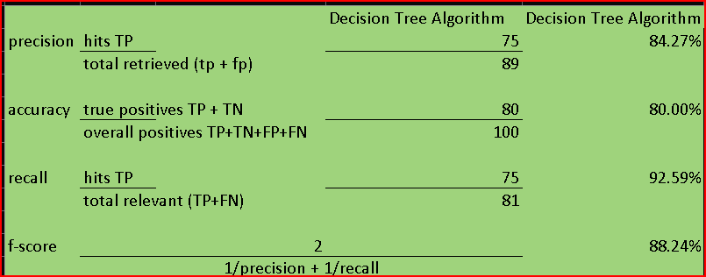

Performance metrics per the final Random Forest data (final)

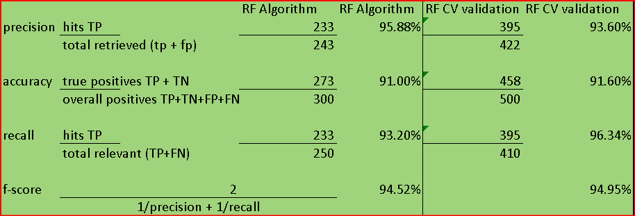

**4** **Model Evaluation**:

Per regression modelling, Horizontal Axis (Fitted Values): *for residuals vs fitted)*

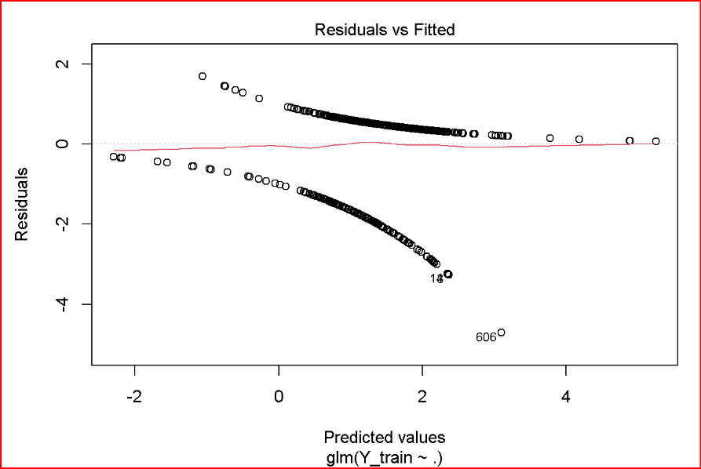

The x-axis represents the predicted or fitted values per the regression model. Each point on the x-axis corresponds to a specific observation.

Vertical Axis (Residuals):

The y-axis represents the residuals, which are the differences between the observed values and the values predicted by the model.

Pattern and Spread:

A random scatter of points with no clear pattern suggests that the residuals are evenly distributed around zero, indicating that the model is capturing the underlying relationships in the data. The graph above lacks a scatter but rather displays a pattern around the **red line.**

Homoscedasticity vs Heteroscedasticity:

Homoscedasticity means the spread of residuals is consistent across all levels of the predicted values. Here we see what is known as heteroscedasticity meaning that the variability in the response is changing as the predicted value increases.

Outliers:

There are few points that are far from the main cluster. These *Outliers* can have a significant impact on regression results and note data points that are not well-described by the model.

Fan-shaped Residuals:

The fan like graph indicates the presence of heteroskedasticity this suggests a violation of the assumption of constant variance.

In summary, a well-behaved "residuals vs fitted" plot should exhibit a random scatter of points with no discernible patterns, clusters, or trends. Since a pattern and outliers can be noticed, this is an indication that the model assumptions are not fully met, and further investigation or model refinement is needed.

**Normal Q-Q plot**

The points line up along a line towards the center of the graph, but curve/fall off in the edges or towards the ends. Normal QQ plots that exhibit this behavior usually mean the data has more extreme values than would be expected if they truly came from a normal distribution. Quantiles are often referred to as ‘percentiles’. These are points in the data above where a certain proportion of the relevant data falls.

**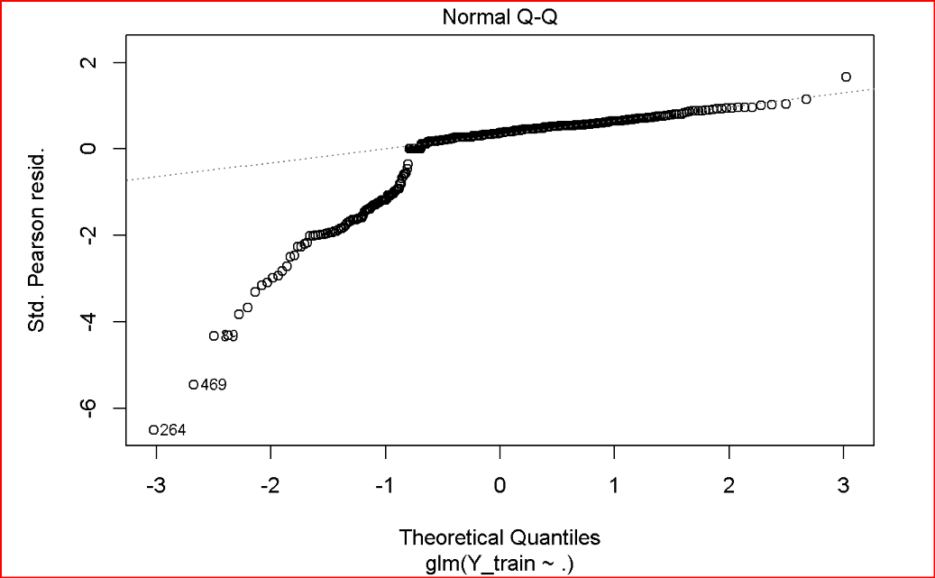**

**Scale location**

The scale-location plot is very similar to residuals vs fitted, but simplifies analysis of the homoskedasticity assumption. It takes the square root of the absolute value of standardized residuals instead of plotting the residuals themselves.

We check for two points:

A - That the red line is approximately horizontal suggesting the average magnitude of the standardized residuals isn’t changing much as a function of the fitted values.

B - That the spread around the red line doesn’t vary with the fitted values. Then the variability of magnitudes doesn’t vary much as a function of the fitted values.

We see that for this plot, the first point is somewhat satisfied, while the second condition is a bit less clear. It’s likely due to outliers and need to be investigated further.

**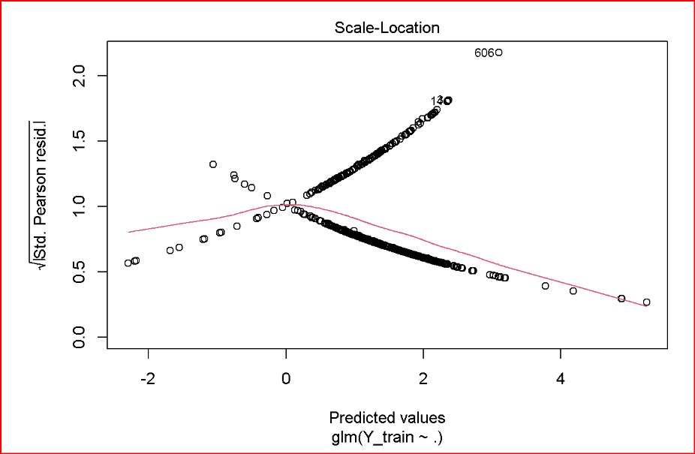**

**Residuals vs Leverage plot**: In this plot we see that there are several points that have high residual and high leverage. The points that lie close to or outside of the dashed red curves are worth investigating further (*if there were dashed curves around the corners usually, they would indicate presence of outliers on the plot*).

**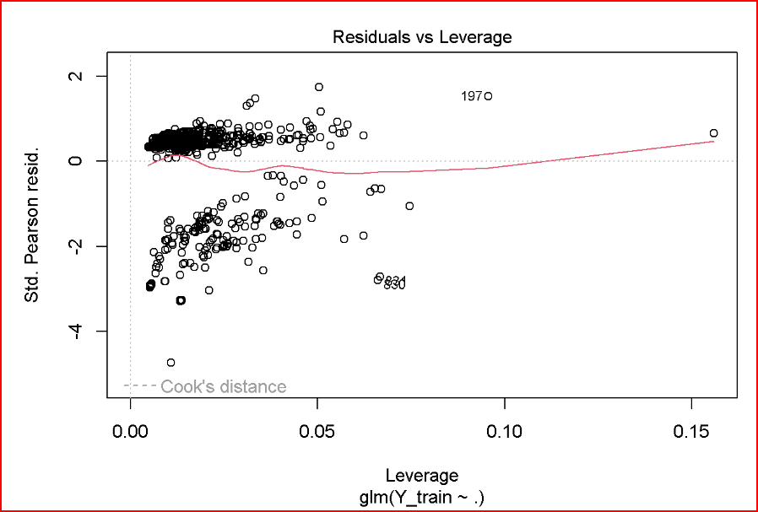**

**Per Random Forest’s model evaluation:**

Both the Random Forest and Cross-Validation models seem to perform well based on the provided metrics.

The Random Forest model has higher precision, which means it is better at avoiding false positives.

The Cross-Validation model has higher recall, indicating better identification of positive instances.

The F-score considers both precision and recall and is high in both cases, suggesting a good overall model performance.



**5** **Proof of concept, interpretation and explanation**:

Below the graph, some meaningful insights are noted below.

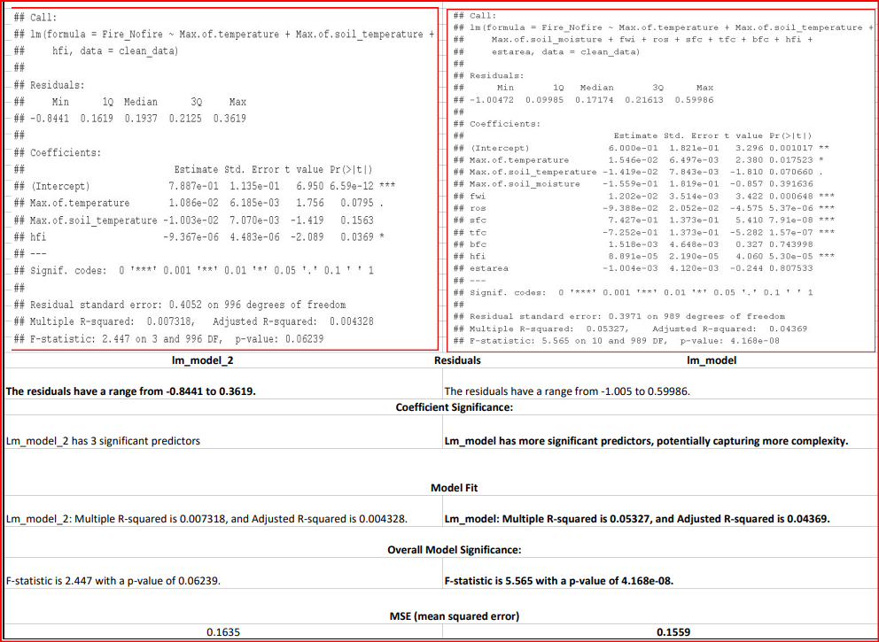

*In summary, lm\_model appears to have a better-fitting model with more predictors showing significance.*

Residuals:

Min, 1Q, Median, 3Q, Max: These values represent the minimum, first quartile, median, third quartile, and maximum values of the residuals, which are the differences between the observed and predicted values.

Coefficients:

Estimate: These are the estimated coefficients for each predictor variable in the model.

Std. Error: Standard errors indicate the variability of the estimate.

t value: The t-value measures the *number of standard deviations* a coefficient estimate is from zero. Larger t-values suggest more evidence against the null hypothesis (that the coefficient is zero). *A larger t-value (in absolute terms) suggests a more significant result*.

Pr(>|t|): The p-value associated with each coefficient. Lower p-values indicate stronger evidence against the null hypothesis. *If the p-value is less than 0.05, it is generally considered statistically significant to reject the null hypothesis.*

Residual Standard Error:

The residual standard error is an estimate of the standard deviation of the residuals.

Multiple R-squared and Adjusted R-squared:

Multiple R-squared: The value represents the proportion of variance in the dependent variable explained by the model.

Adjusted R-squared value is an adjusted version of R-squared that penalizes for the number of predictors in the model.

F-statistic:

F-statistic: This tests the overall significance of the model. A higher F-statistic suggests that at least one predictor variable is significantly related to the dependent variable.

Interpretation:

The 'Estimate' column indicates the direction and strength of the relationship between each predictor variable and the response variable ('Fire\_Nofire').

***The overall regression model does not explain a large proportion of the variance in the response variable (low R-squared value). The model needs to be further examined versus the individual coefficients and their significance levels to understand the relationships between predictor variable and the response. Adjustments are likely needed to improve model performance****.*

**6** **Limitations and Future Directions**:

Acknowledge the limitations of the linear regression model. Discuss any assumptions that may not hold for your data.

*Linear regression is a powerful tool, but does have limitations. Here are some of the key limitations of the linear regression model:*

*Linearity Assumption: Linear regression assumes a linear relationship between the independent and dependent variables. If the true relationship is nonlinear, the model may not perform well.*

*Assumption of Independence: The observations are assumed to be independent. If there is autocorrelation or serial correlation in the residuals, it can lead to inefficient parameter estimates.*

*Homoscedasticity: The model assumes homoscedasticity, meaning that the variance of the residuals is constant across all levels of the independent variables. If the variance is not constant (heteroscedasticity), it can affect the efficiency of the estimates.*

*Normality of Residuals: The residuals are assumed to be normally distributed. If the residuals deviate from a normal distribution, it may affect the statistical tests and confidence intervals associated with the model.*

*Outliers: Linear regression is sensitive to outliers and influential points. Outliers can strongly influence the estimates of the regression coefficients.*

*Causation: While linear regression can identify associations between variables, it cannot establish causation. Correlation does not imply causation, and additional evidence is needed to make causal claims.*

*Non-constant Effects Over Time: If the relationship between variables changes over time, linear regression may not capture this dynamic behavior.*

*Limited to Linear Relationships: As the name suggests, linear regression models are specifically designed for linear relationships. If the relationship is inherently nonlinear, other models might be more appropriate.*

This paper deals with a relentless and dangerous threat that significantly disrupts our lives emotionally, economically as well as importantly enough, environmentally. Each year, thousands of forest areas around the world are destroyed by fire. The same amount is lost to logging and agriculture combined. These fires not only damage the structure and composition of forests, but they also open up forests to invasive species, threaten biological diversity, alter water cycles and soil fertility, and destroy the livelihoods of the general residential indigenous communities which thrive in and around the forests. Hence, in order to reduce the damages caused by this disaster, I have attempted to propose a solution that predicts wildfires by making use of a very rich source of big data which includes 11 parameters. Moving forward, this data need to be extracted from different provincial fire agencies, monitored continuously with additional criteria identified earlier to make a robust prediction environment.

Future works will mainly consist of strengthening the model by including detailed weather data variables, ground thermal energy data, lightning sensors’ perimeter with satellite imagery and the ***distance to closest source of water bodies in case of fire (intuition of experienced firefighters including native residents with knowledge about the surrounding land)***. As a start, the five weather parameters that can affect wildfires: Altitude, Snow Cover, Air Temperature, Wind, and Soil Moisture.

• ***Altitude and its landscape*** plays a major role in determining the streamlined variables (oxygen, CO2)

*•* ***Snow Cover at the end of the winter season if applicable***

• **Air Temperature (and the # of days with extreme temps)** heats trees and crops, which makes them sensitive toward catching fire with ease.

• **The Wind (or its direction)** has the most prominent and strongest impact on wildfires behaviors. Wind speed and direction are unpredictable. Besides, winds supply the fire with the needed oxygen, pushing the fire to move faster across the land.

• **Soil Moisture** directly affects wildfires. When the soil moisture is low, the risk of catching fires is high. Conversely, high soil moisture lowers the chances of catching fires.

***Closest source of water*** *though irrelevant in predicting wildfires is an important attribute for fire mitigating strategies and should be included when putting out fires with the ground team members with the help of aircrafts and drones.*

**REFERENCE****S:**

1. [Record wildfires in Canada should be a wake-up call](1%09https:/www.aljazeera.com/news/2023/6/7/canadas-record-wildfires-should-be-wake-up-call-experts-warn)
2. [Alberta to harness artificial intelligence](https://www.cbc.ca/news/canada/edmonton/alberta-wildfires-artificial-intelligence-technology-forest-fire-1.7007279)
3. Cilli, R., Elia, M., D’Este, M. et al. Explainable artificial intelligence (XAI) detects wildfire occurrence in the Mediterranean countries of Southern Europe. Sci Rep 12, 16349 (2022). <https://doi.org/10.1038/s41598-022-20347-9>
4. [Moncton, Canada: Technology uses satellite images to quickly detect fires and predict spread](https://www.cbc.ca/news/canada/new-brunswick/moncton-researchers-developing-artificial-intelligence-to-fight-wildfires-1.7039569)
5. [Two years after the Fort McMurray disaster, there are new tools on the horizon](https://www.ualberta.ca/newtrail/ideas/fighting-fire-with-data.html)
6. [AI program model that can 76% of wildfires](https://www.weforum.org/agenda/2023/09/ai-model-prevent-wildfires/)

AI Solutions with AI for Wildfire Containment in Remote Canadian Territories

Ali Baloch, ID # 501214761 dated 16-Oct-2023

Table of Contents (literature review)

1. [Introduction](#_Toc452457337)
2. [Critical analysis of current limitations](#_Limitations_of_the)
3. [Was](#_Was_this_actually) this [actually](#_Was_this_actually) ever done before?...................................................................
4. [Any](#_Toc452457339)thing [relevant](#_Anyone_done_something) that was done before this? ……………………………………
5. [Where](#_Toc452457339) does [this](#_Your_work_with) research fit?..............................................................................
6. Is this [research](#_Is_this_research) worth doing?.............................................................................
7. Relevant [articles](#_Relevant_articles,_journals), journals and research papers………………………………….
8. [Dataset and Data Description………………………….](#_Dataset_and_Data)..........................................

[**References**](#_REFERENCES:_1)

[Figure 2](#_Figure_2_(3)

# Introduction

1. **What do you already know about the topic?**

Wildfires often start small and initially go unnoticed, but have the capacity to spread very quickly. As they travel across large areas, they ignite brush, trees, homes and buildings. Burning debris can be thrown up to two kilometres ahead of a wildfire. Sparks and embers can ignite materials on or near your home causing severe damage. As witnessed recently, uncontrolled burning due to human activity or has harmful effects travelling all the way to USA and beyond posing significant health and environmental concerns.

On average in Canada, wildfires burn 2.5 million ha/year, nearly half the size of Nova Scotia ([source: getprepared.gc.ca](https://www.getprepared.gc.ca/cnt/hzd/wldfrs-en.aspx)). Much of the country is at risk of wildfires due to hotter temperatures, drought conditions and climate change phenomena. Most wildfires occur between April and September; and with climate changes, the risk of bigger wildfires are becoming a reality every other year, if not every year and putting unimaginable amount environmental resources and human lives at huge risk.

The wildfires raging in many parts of Canada this spring are part of an overall increase in more powerful blazes, experts say. But the details behind this trend are more complex than just counting the fires, or damage done, per year.

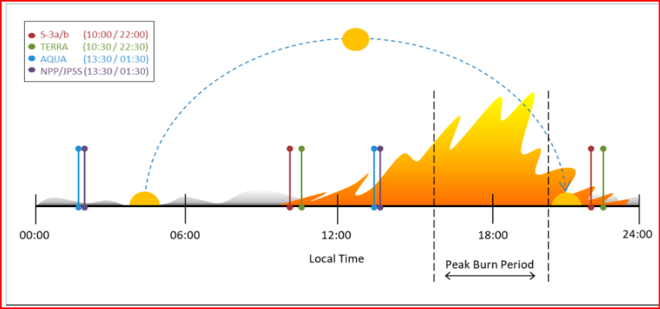

*Figure 1: currently available active-fire low-earth-orbiting satellite observations from instruments such as SLSTR (Sentinel-3a/b), MODIS (TERRA/AQUA), and VIIRS (NPP/JPSS) fail to observe wildfires during the most active portions of the day.*

In 2019 the Canadian Space Agency (CSA) started the improvement of a dedicated wildfire monitoring satellite “WildFireSat” mission. WildFireSat (WFS) intends to leverage *uncooled microbolometer technology* developed by the CSA and Institut National d’Optique (INO). Since earlier versions, the detector technology has continued to evolve, while new Low Earth Orbit (LEO) wildfire products (e.g., from the Visible Infrared Imaging Radiometer Suite (VIIRS) and Sea and Land Surface Temperature Radiometer (SLSTR); have filled some **temporal coverage gaps** ([Figure 1](https://www.mdpi.com/1424-8220/20/18/5081#fig_body_display_sensors-20-05081-f001)), which will improve the feasibility of a targeted wildfire monitoring mission. (Source: <https://www.mdpi.com/1424-8220/20/18/5081#B43-sensors-20-05081>)

Since the 1980s, lightning location systems have been used to direct fire patrol flights to areas of lightning strikes after the occurrence of lightning storms. Currently, the Meteorological Service of Canada (MSC) operates a national lightning location system to which provincial and territorial agencies may subscribe on a cost-recovery basis.

Many provinces use forms of zonation whereby fires in the managed forest and other high-value areas are suppressed more vigorously than fires in other areas. The less vigorously protected areas are known by different names, such as observation zones (Saskatchewan) and ecological fire management zones (Alberta). In other jurisdictions, including British Columbia, the threat posed by an individual fire is evaluated and action taken on a case-by-case basis. In the Yukon and the Northwest Territories, suppression effort is focused on areas around settlements.

Provincial and territorial governments spend a significant proportion of their overall budgets on fire suppression. However, because of the annual variation in fire weather, almost every fire management agency in Canada experiences considerable annual variation in fire load and expenditures. For example, in 2003 the British Columbia Ministry of Forests paid $370 million for fire suppression, much more than the average of $53 million over the preceding 10 years (source: BC Ministry of Forests and Range Protection Program).

Many agencies have established targets for measuring the success of fire management within the managed forest. In British Columbia, for example, initial attack is judged successful if unwanted wildfires are limited to 4 hectares. Cumming (2005) determined the degree of effectiveness of fire suppression in reducing the size of fires in northern Alberta through statistical modelling. However, the return on investment through increased timber production and value has not been well quantified.

In addition, many local governments have agreements or operating guidelines with provincial agencies to draw on provincial resources if wildland fires escape initial attack. In some jurisdictions, including New Brunswick, which does not use provincial initial attack crews, firefighters from volunteer fire departments are often the first responders. The number of wildland and Wildland-Inland Interface WUI fires attended by local fire departments in Canada is not accounted for in national reporting and so is unknown, but it is believed to be significant.

# Limitations of the current approach

1. **What do you have to say critically about what is already known?**

Using satellites for detecting fires helps as they can cover all of Canada multiple times daily, at a low cost. This makes them effective for detecting fires in remote, unpopulated regions, where conventional fire monitoring is less intensive. Thick smoke plumes from forest fires, often extending several hundred kilometers, can also be identified by means of satellite imagery which has some limitations.

The test images used by the fire algorithms to remove "false alarms" sometimes fail, leading to incorrect records of fires. Considering the large number about 9.5 million of satellite pixels examined each day across Canada, the error rate is extremely low. A fire hotspot can be confirmed when a conical smoke plume is observed being produced by it. However, it is sometimes impossible to see a plume from a small fire or a fire obstructed from view by nearby clouds. The algorithms cannot detect fires through thick cloud or smoke. A large fire may therefore go undetected for several days and then appear or reappear later; a small fire may burn and die out without ever being detected.

The time lapse between satellite image acquisition and image distribution on the CWFIS site is between 1 and 7 hours, depending on the sensor and processing time. This delay, along with the coarse resolution, limits the utility of satellite detection for tactical fire operations.

The actual size of the actively burning area cannot be determined from satellite imagery. A 1-km² hotspot pixel may represent a fire as small as 100 m². In addition, an intense fire covering an area less than 1 km² may actually show up as a cluster of several hotspot pixels. This is the result of the varying size and spatial overlap of the raw, unprojected pixels.

For the last couple of decades, and with the ongoing challenges faced due to climate change, more record-breaking summer temperatures have increased around the globe, more severe wildfires, their frequencies and forces are being predicted to increase. Canadian Forest Fire Danger Rating System (CFFDRS) has been largely credited with accomplishing many improvements and its products or subsystems known as *Fire Behavior Prediction System (FBP) and Fire Weather Index (FWI) system* are still used to this day. With the burdening increase of risk of wildfires, it does not come as a surprise that the most recent wildfires overwhelmed the Canada wildfire management system with its limited resources in strategic places. Along with FBP and FWI, the machine learning prediction system necessitates to create a serious and innovative wildland fire tactic, its management in the short term & in the near future. This machine learning method will further enhance the key knowledge to suppress or control fires and also manage to validate data and close the gap from other sources: satellite imagery, infrared sensors, remote sensors, aircrafts with thermal infrared sensors

The methods used in the last 50-70 years to fight or attack wildfires based on *smoke detection, aircraft with infrared sensors, few satellites orbiting the Earth, remote sensors*, weather forest conditions and other environmental factors while waiting and reacting need key overhauling in the age of climate change, with current available technology and AI algorithms to better analyze, predict and control to minimize damages increasing into **several** **billions**. Wildfire remote sensing has been recognized for its capacity to detect wildfires ([[1]](#_REFERENCES:)). However, there is a significant gap between what is required for “early” detection (e.g., identifying small sub-canopy wildfires) for wildfires that require suppression and what can be accomplished reliably with a few satellite sensors currently in use.

This can be achieved with cooperation from various areas in the form of duty officers, artificial intelligence tools, satellite and spatial imagery in key strategic places. There are many intangible unknowns about this strategy going back 50 years where the mental and physiological stress that comes with the job has gone unnoticed whether be it an individual or families of wildfire fighters and even the wildlife.

Wildfires can spread quickly, forcing your family and even your whole community to evacuate in a hurry (Yellowknife, NWT and Kamloops, BC in summer of 2023). If you live in a region at risk of wildfires, make a plan to be sure you and your loved ones will be safe if a fire hits your community.

The [Canadian Wildland Fire Information System](http://cwfis.cfs.nrcan.gc.ca/home) creates daily maps tracking the behaviour of fires throughout the year. During the fire season, the [Canadian Interagency Forest Fire Centre](http://www.ciffc.ca/index.php) provides up-to-date reports on wildfires across the country.

Responses to wildfires differ across Canada [7] and choice from a “Full Response” (immediate, aggressive initial/sustained attack), to “Monitored Response” (observation and periodic reassessment; [8]), guided either by zonation, or wildfire specific conditions termed “appropriate response” [9]. In situations with increased wildfire activity, the suppression capacity can be rapidly overwhelmed, resulting in escaped wildfires that may burn very large areas [10,11]. These larger wildfires represent only 3% of the number of wildfires in Canada, yet they account for 97% of the area burned [7,12], and require substantially more resources to manage [13,14]. This literature review does not cover much about other important key areas of Canadian wildland fire science but are equally critical and significant e.g. *fire history, fire interval, fire regime, depth of burn, fire mgmt. planning, fuel management, fuel moisture, among others*.

What is missing from the above is the development of Canada wide prediction system based on machine learning and the intuition that comes from duty officers with years of experience and the land knowledge of the elders based on centuries worth of knowledge.

# Was this actually ever done before?

### Has anyone else ever done anything exactly the same?

A 2019 detailed study by post graduates was done at the University of CADI AYYAD, Marrakesh Morocco [2] and a simple dataset was used where the prediction of classification was based on two classifiers: Fire and No\_fire. In their simulation, two data mining algorithms were used: Neural Networks and SVM and the results were validated based on 3 different methods: (classification metrics, cross-validation, and regularization.

([6 https://www.sciencedirect.com/science/article/abs/pii/S0379711218303941](6%20https://www.sciencedirect.com/science/article/abs/pii/S0379711218303941)).

.

# Anyone done something like this which is relevant

1. Has anyone else done anything that is related? Alberta is the first province in Cananda to use AI in its fight against the wildfires and used it first time 2022. With the help of AI-powered tool developed by AltaML (<https://altaml.com/>)by an Edmonton based developer, Alberta Wildfire used it to make key decisions and use resources more strategically. This tool leverages thousands of data facts to predict the next day’s chances of new fires in a region.

In 2022, Alberta Wildfire (first in Canada) started using an AI-powered tool to help duty officers make decisions and use resources more strategically not knowing the sheer speed and size of these wildfires or even if they would appear or not.

<https://news.microsoft.com/source/features/ai/ai-alberta-canada-wildfire-firefighting/>

Ed Trenchard, a longtime Alberta Wildfire manager knows this first hand where tough decisions of spreading low resources to attack wildfires, have to be made in the face of such volatile emergencies and also ensure safe evacuations of nearby residents.

# Your work with this research fits where?

1. Where does your work fit in with what has gone before? I believe this kind of work is in its infancy or rather first decade of development in Canada as this machine learning model is initiated and maintained with more relevant data coming from duty officers, satellite imagery, remote sensors and the soon-to-be-launched WildFireSat in 2029. While the research work, I am doing and its approach based on vegetation index, weather, wind direction, soil moisture and other criteria can definitely open more doors but does have the need for more collaboration towards better management of wildfires and minimizing losses (economic, environmental, psychological, health). All this work based on AI tool does lack intuition which is based on years of experienced firefighters’ knowledge. Since the start of Alberta’s machine learning project in 2022 based on the historical data, this is bound to get better in conjunction with additional knowledge provided by the elders in the remote communities.

# Is this research worth doing?

1. Why is your research worth doing in the light of what has already been done? (Silverman, 2017)

*At this point, I believe the future of Canada wildfire management system will largely be enhanced with the development wildland fire science machine learning.*

In the age of machine learning, its time to revisit the fire management plan in remote areas of Canada (not just in Alberta) as the most environmental damage is done in these remote areas and they are more vulnerable due to inaccessibility. This tool, if not already, will also be able to distinguish if the wildfire can be designated a wildfire or mere campfires during a busy camping or holiday season. Challenges will surely arise when the fire danger is moderate to severe and some less experienced officers need to make judgement call where to apply limited resources (bulldozers, helicopters, water carriers) which can be expensive if not used compared to the region where it could have been used.

Canada spends about $1 billion annually combatting wildfires. However, indirect costs may rise to several billion dollars per year stemming from property loss, damaged infrastructure, industrial shutdowns, evacuations, health-related expenses, and economic losses in a variety of sectors including tourism, forestry, and energy. The 2016 Fort McMurray wildfire was the most expensive natural disaster in Canadian history, with a total cost of approximately $9 billion.

While the goal of using machine-learning and science-based models, in conjunction with intuition from experienced duty officers and the elders’ knowledge of the wildland environment is to provide ground intelligence to key decision-makers has been of utmost priority, its importance will continue to mitigate risk exposure. There is an ongoing effort to develop the next generation of the Canadian FWI and FBP Systems (WildFireSat satellite system, to launch in 2029,) to provide improved flexibility and a broader application in the challenging decision-making environment faced by modern fire managers. For instance, a more flexible fuel modelling structure is under development to address the modern need for fire behaviour prediction capacity. Such a task requires a comprehensive redesign of many of the models incorporated with AI; however, the benefits will be largely significant as progress is measured and tracked. With the development of machine learning, improvements to the FWI and FBP Systems will only provide better opportunities for new technological developments and key data sources, now available as remotely sensed products such as Lidar and infrared or multiscale mapping from satellite, aircraft, drones or pilotless aerial platforms. In conjunction with improvements in weather forecasting & other relevant projections, these data points or hot spots will enhance the core Canadian fire information products (FWI, FBP) of the CFFDRS for its users.

Fire and land management challenges have grown over the preceding decades and the need to more broadly inform decision-making every season becomes more paramount. Therefore, researchers have continued to adopt new approaches and technological advances to overcome management challenges. The complexity of these problems highlights the opportunity to address future trials using OR, machine learning, and artificial intelligence to enhance wildland fire science and management. As computational power increases and large data sets become more available (including remotely sensed data), the use of machine learning has the potential to improve many aspects of fire science in innovative ways including operational fire management, occurrence prediction, burn probability mapping, fuel treatment assessment, and forest and landscape planning (Jain et al. 2020). Furthermore, the continual advancement in remote sensing technologies has greatly helped scientists to monitor and better understand the dynamics of wildland fire. The WildFireSat satellite system, which is scheduled to launch in 2029, is currently being developed to enhance Canada’s ability to manage wildland fires in the future (<https://www.asc-csa.gc.ca/eng/satellites/wildfiresat/default.asp>).

# Relevant articles, journals & research papers

1. Reviews of articles, technical papers

**1** <https://www.nytimes.com/2023/07/21/world/canada/canada-wildfire-fighting.html>

***How to Fight Canada’s Wildfires in the Era of Climate Change***

Mega Wildfires have increased in speed and size posing health risks to millions and damaging much more than what is quantifiable in terms of dollars. Quebec recorded its biggest blaze this past summer. Even as thousands of Canadians and firefighters from abroad continued to battle more than 900 fires, Canada’s record-shattering wildfire season has made it clear that traditional and current firefighting methods are no longer enough, experts in wildfires and forests say. Newer strategies are critical because wildfires, in the enormous Canada (home to 3rd largest forest reserves, USA is the 4th), are expected to become increasingly difficult to combat as they grow more frequent and bigger in the hotter and drier conditions resulting from climate change.

2 <https://globalnews.ca/news/9757305/how-to-put-out-a-wildfire-canada/>

***What does it take to put out a wildfire? Here’s how Canada is fighting them***

The techniques used to put out the wildfires varies depending on location, but ultimately, they depend on the ground folks equipped with equipment digging out hot spots & these are the fire-fighting crew who are going to put out the last hot spot out even if it is a bit underground. What can be done when the fire fighting capacity is 50 but the wildfires are 2 to 3 times than 50? How can the resources be distributed strategically to put out the materially significant wildfires? Strategies constantly keep changing to controlling the fires, evacuation orders or protecting human lives, critical infrastructure, and at times to control one fire and then being able to control another fire. Water bomber aircraft carrying 6000 litres of water is the first line of attack and must pass every 10-12 minutes to be effective. At the end of the day, the firefighters on the ground are the ones who will extinguish the flame, not only above the ground but underground as well.

3 <https://iopscience.iop.org/article/10.1088/1748-9326/ac7345>

***Western Canada's new wildfire reality needs a new approach to fire management***

All the Wildfire suppression and prevention techniques need to be reorganized with the help of machine learning, with the land knowledge of the Indigenous Nations & communities to lead and engage in wildfire containment tactics that aligns with their centuries’ old values. Consistently and more constantly educating the public on risk reduction techniques, enhancing technical training across cultures and areas of expertise, and collaborating with communities and regional districts on wildfire mitigation. In 2019, the Province of BC became the first jurisdiction in Canada to implement the United Nations Declaration on the Rights of Indigenous Peoples (UNDRIP). Under UNDRIP, BC acknowledges and respects traditional cultural expressions, science, and knowledge, thus transforming how fire and forest statues are interpreted ([3 Hoffman et al 2022](https://iopscience.iop.org/article/10.1088/1748-9326/ac7345#erlac7345bib8)).

As huge, severe wildfires become more common, it is clear that Canada needs to revise its wildfire suppression approach before, during and after the wildfire season. This translates to transforming the current wildfire practices with new ones to reflect both the best available knowledge, enabling the 'boots on the ground' or firefighters on the ground experience, and millennia of Indigenous knowledge ([4 Dickson-Hoyle et al 2021](https://iopscience.iop.org/article/10.1088/1748-9326/ac7345#erlac7345bib6)). Full containment fire suppression tactics are often unrealistic, unsustainable, and environmentally unfavourable in fire-prone landscapes ([5 McWethy et al 2019](https://iopscience.iop.org/article/10.1088/1748-9326/ac7345#erlac7345bib18)).

# [Figure 2](https://iopscience.iop.org/article/10.1088/1748-9326/ac7345" \l "erlac7345f1) ([3 Hoffman et al 2022](https://iopscience.iop.org/article/10.1088/1748-9326/ac7345#erlac7345bib8))

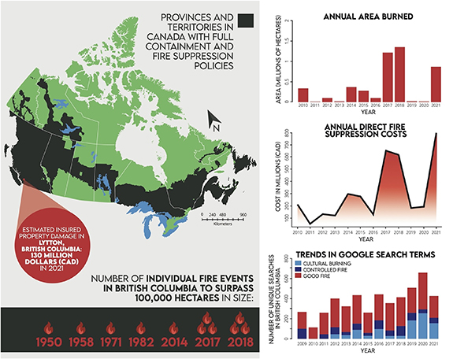

**Left panel**: provinces and territories in Canada with contemporary full wildfire containment and fire suppression policies and response zones (in black; adapted from [Hope et al 2016](https://iopscience.iop.org/article/10.1088/1748-9326/ac7345#erlac7345bib11)). Note that British Columbia (BC) and Alberta (AB) are the only provinces outside of Atlantic Canada with full wildfire containment and suppression policies, with exemptions in AB for National Parks and Department of Defence Lands. The green area represents areas that are under modified response, fuel exclusion zones, or do not have vegetation-climate parameters to support wildfires. The bottom panel shows the number of wildfires to exceed 100 000 hectares in BC over the past century, note that 2017 and 2018 wildfire seasons had three wildfire events exceeding 500 000 hectares.

**Top right**: the trend in annual area burned in millions of hectares in BC from 2010 to 2021, note the three greatest annual area burned totals have occurred since 2017. Right centre: total direct wildfire expenditures in BC since 2010, with 2021 representing the most wildfire expenditures on record. This sum does not include insurable losses and liability lawsuits. Bottom right: we used the 'gtrendsR' package ([Massicotte and Eddelbuettelm 2016](https://iopscience.iop.org/article/10.1088/1748-9326/ac7345#erlac7345bib16)) in R Statistical Software ([2020](https://iopscience.iop.org/article/10.1088/1748-9326/ac7345#erlac7345bib21)) to assess trends in Google search terms including 'cultural burning', 'controlled fire which includes several types of prescribed burns', and 'good fire' in BC since 2009. The numbers represent the search interest relative to the highest point on the chart for the selected region and time. A value of 100 is the peak popularity of the term, whilst a value of 50 means that the term is half as popular. Each data point is divided by the total searches of the geography and time range it represents to compare relative popularity. Trends data represents an unbiased sampling of aggregated data and regional search interest for a topic and is the interest for that topic in a given region as a proportion of all searches on all topics on Google in that same place and time. Data used in this figure were openly sourced from Natural Resources Canada-Open Government License, The National Forestry Database, BC Wildfire Service, and the Google search engine database.

4 <https://www.theguardian.com/world/2023/jun/29/canada-wildfires-us-crews-shift-strategy>

*Mueller, firefighter from California said after 17 days in Alberta that he and his team were relieved by an Australian one. Mexican hand crews had already started to show up to aid in suppression. “It was four nations on one fire – pretty cool.”*

This was the first time in the last decade that international firefighters came to Canada from USA, Mexico, New Zealand, France, Costa Rica and Australia. Also, a first in recent memory, was the poor air quality in several USA cities like Detroit, Chicago, New York due to the thick smoke blanket coming from the Canadian wildfires.

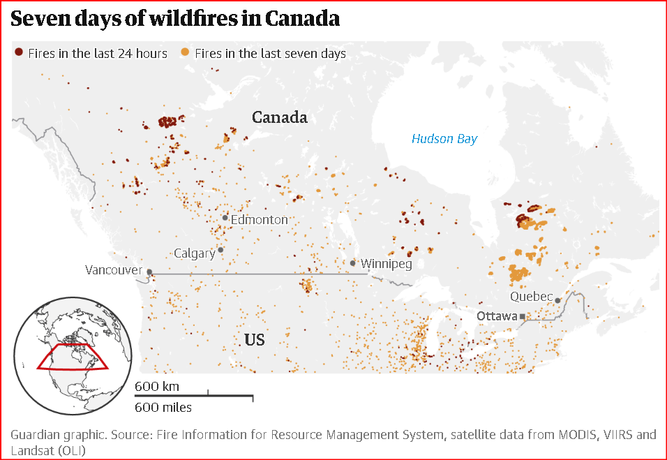

With limited resources to battle the wildfires, strategies keep changing as some of these fires are too difficult or too risky so they are left to run their course. The ultimate goal is to save human lives including the lives of firefighting crew. Different nations around the world have varied strategies to fight wildfires as the American firefighters work on a 24-hour shift whereas in Alberta, Canada it’s a 12-hour shift to take a break and avoid fatigue and stress – difference due to terrain, weather conditions, risk, safety of crew among other criteria. On the ground, reality dictates everything, and “open communication delivers the best results” and all the firefighters are comparing notes to make the best-informed decision.

5 <https://www.cbc.ca/news/canada/british-columbia/b-c-forests-practices-board-report-wildfire-strategies-1.6894280> *by Dirk Meissner, The Canadian Press, Posted: Jun 30, 2023*

The B.C. Forests Practices Board is calling on the provincial government to undertake a "paradigm shift" in how it manages forests, saying wildfire risk mitigation currently focuses on areas near communities but leaves the wider forest landscape "severely vulnerable.'' Another avenue for risk management is to create more fire resilient forest areas to avoid catastrophic wildfires in addition to collaboration with the Indigenous communities with knowledge of the land to better manage forest with fire management.

***According to the report, B.C. spent about $800 million on fire suppression in 2021, but the indirect costs associated with the wildfire season could have been up to $24 billion.***

*'The key is there's an urgency to this': B.C. Forests Practices Board chair.* The article notes that Donnie Creek wildfire was the biggest wildfire in recent memory (bigger than PEI) and damaging the resource base, the habitat and the ecosystem. Out of the 390,000 square kilometres that is susceptible to fire risk, 34,000 square kilometres was already burnt during the last three biggest fires in 2017, 2018 and 2021.

6 [**https://www.theglobeandmail.com/canada/british-columbia/article-canada-must-change-how-it-approaches-and-funds-wildfire-management/**](https://www.theglobeandmail.com/canada/british-columbia/article-canada-must-change-how-it-approaches-and-funds-wildfire-management/)

***Canada must change how it approaches and funds wildfire management***

Wildfires are not unusual in Canada but the scale of wildfires stretching from British Columbia to Quebec is unprecedented. *The United Nations International Strategy for Disaster Reduction (UNISDR) identified the major flaw in fire management in 2020: We spend an inordinate amount of money on response (firefighting) and recovery (rebuilding after a fire) and not enough on mitigation and prevention.* It was further noted that 87% goes to disaster-related response efforts and 13% goes towards managing the risks.The province of BC had response bill for the fire years of 2017, 2018 and 2021 more than $2-billion, while fire-related recovery costs were more than $10 billion. Investing in mitigation will surely lead to issues about how money is prioritized and spent. *Those most affected by wildfires – rural, northern and isolated Indigenous and non-Indigenous communities – are usually last in line for fire mitigation funding. This is a serious social-justice issue.*

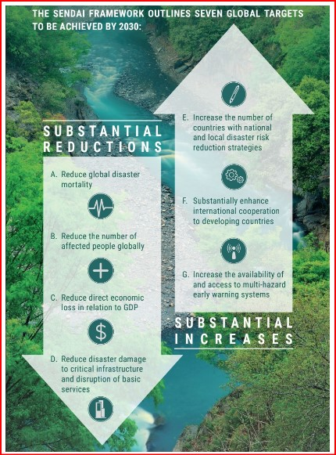Sendai Framework works hand in hand with the other 2030 Agenda agreements, including the Paris Agreement on Climate Change. It was endorsed by UN General Assembly in 2015 and advocates for the substantial reduction of disaster risk and losses in lives, livelihoods and health and in the economic, physical, social, cultural and environmental assets of persons, businesses, communities and countries (source: [undrr.org](https://www.undrr.org/implementing-sendai-framework/what-sendai-framework)). The province of BC, Canada has adopted this framework and not much has been spent on mitigation efforts.

In B.C., there is also unfairness in terms of who is most affected by wildfires. Compared to urban centres, rural, northern and isolated Indigenous and non-Indigenous communities are most affected both during the event and often for years afterward. There is a negative toll during & after the wildfire season which leads to physical and emotional health challenges. Financial help also lags for rural, northern and isolated Indigenous and non-Indigenous communities versus larger urban centres.

# Dataset Data Description & Methodology (GitHub link: <https://github.com/alibaloch2023/TMU_CIND820>) discuss your dataset, some plots, some visualizations, descriptive statistics, and correlation analysis.

**Dataset (1)**: <https://data.mendeley.com/datasets/85t28npyv7/1> (3 attributes 1 class, 1718 data points)

The original study’s dataset is based on *Remote Sensing* and this developing technology offers the advantages of consistent, repeatable, large-area coverage, and can easily provide a huge amount of data from remote regions. First, this remote Sensing data includes the *Normalized Difference Vegetation Index (*[*NDVI*](https://neo.gsfc.nasa.gov/view.php?datasetId=MOD_NDVI_16&date=2023-06-01)*)*, which is a vegetation index that indicates the state of crop health; it can be used to assess spatiotemporal changes in green vegetation acting as a fuel agent for wildfires. NDVI values are between 0 and 1, values near 0 indicate very sparse

vegetation and values near 1 indicate dense vegetation. Second, Land Surface Temperature (LST) represents the radiative skin temperature of the land surface derived from solar radiation, it depends on the vegetation cover and the soil moisture. It is used to detect water-stressed crops; the higher it gets, the higher the level of stress. Third, Burned\_Area was selected based some fire zones that occurred in Canada’s forest between 2013 and 2014, and were downloaded from the official website of the [Natural Resources Canada](http://www.nrcan.gc.ca/home), containing data for fire zones; varying sizes, the nature of its vegetation. Fourth, class of Fire & No\_fire for each fire zone, this class was added where the fire did or did not occur.

**Dataset (2)**: Wildfires can be characterized by big data’s three features: volume, variety, and velocity, defined as three “V” dimensions. This test dataset based on BURN-P3 (*prediction, planning, and planning* used for spatial fire simulation) software consisting of 13 attributes with 4850 records based on Canada Wildfire Org: <https://spyd.com/fgm.ca/test_files_englishV4_7.zip>

**Tentative Methodology**: The plan is to use the **dataset1** by the study authors, add more detailed attributes based on **dataset2** to replicate and compare the results of the original study**.**

|  |  |  |  |
| --- | --- | --- | --- |
| Column | Name | Type | Description |
| 1 | wx\_zone | Integer | Weather zone |
| 2 | season | Integer | Season |
| 3 | temp | Real | Temperature |
| 4 | rh | Real | Relative humidity |
| 5 | ws | Real | Wind speed km/h |
| 6 | wd | Real | Wind direction 0-360 degrees |
| 7 | prec | Real | Precipitation in mm |
| 8 | ffmmc | Real | Fine fuel moisture code |
| 9 | dmc | Real | Duff moisture code |
| 10 | dc | Real | Drought code |
| 11 | isi | Real | Initial Spread Index |
| 12 | bui | Real | Buildup Index |
| 13 | fwi | Real | Fire weather Index FWI |

*Figure 3*: The above chart summarizes the methodology or approach to add 13 more attributes to the original study and compare the results to the original metrics. There are many more variables in terms of spatial images, satellite pictures, infra-red spectrometers, etc. to validate the data presented in this paper to better analyze and eventually manage the risks with limited resources during the fire management season between all relevant Canadian wildfire management agencies.

# REFERENCES:

1. Flannigan, M.D.; Vonder Haar, T.H. Forest fire monitoring using NOAA satellite AVHRR. *Can. J. For. Res.* **1986**, *16*, 975–982. [[**Google Scholar**](https://scholar.google.com/scholar_lookup?title=Forest+fire+monitoring+using+NOAA+satellite+AVHRR&author=Flannigan,+M.D.&author=Vonder+Haar,+T.H.&publication_year=1986&journal=Can.+J.+For.+Res.&volume=16&pages=975%E2%80%93982&doi=10.1139/x86-171)]
2. ([OULAD SAYAD, YOUNES; Mousannif, Hajar; Al Moatassime, Hassan (2019), “Data for: Predictive Modeling of Forest Fires: A New Dataset and Machine Learning Approach”, Mendeley Data, V1, doi: 10.17632/85t28npyv7.1](https://d.docs.live.net/cb7af721f030915f/Documents/OULAD%20SAYAD,%20YOUNES;%20Mousannif,%20Hajar;%20Al%20Moatassime,%20Hassan%20(2019),%20))
3. Hoffman K M, Davis E L, Wickham S B, Schang K, Johnson A, Larking T, Lauriault P N, Le N Q, Swerdfager E and Trant A J 2021 Conservation of Earth's biodiversity is embedded in Indigenous fire stewardship Proc. Natl Acad. Sci. 118 e21050731 18
4. Dickson-Hoyle S, Ignace R E, Ignace M B, Hagerman S M, Daniels L D and Copes-Gerbitz K 2021 Walking on two legs: a pathway of Indigenous restoration and reconciliation in fire-adapted landscapes Restor. Ecol. 30 e13566
5. McWethy D B et al 2019 Rethinking resilience to wildfire Nat. Sustain. 2 797–804
6. Younes Oulad Sayad, Hajar Mousannif, Hassan Al Moatassime,Predictive modeling of wildfires: A new dataset and machine learning approach, Fire Safety Journal, Volume 104 <https://doi.org/10.1016/j.firesaf.2019.01.006>
7. Stocks, B.J.; Mason, J.A.; Todd, J.B.; Bosch, E.M.; Wotton, B.M.; Amiro, B.D.; Flannigan, M.D.; Hirsch, K.G.; Logan, K.A.; Martell, D.L.; et al. Large forest fires in Canada, 1959–1997. *J. Geophys. Res.* **2002**, *108*. [**[CrossRef](https://doi.org/10.1029/2001JD000484" \t "_blank)**]
8. CIFFC Glossary Task Team and Training Working Group. *Canadian Wildland Fire Management Glossary*; Canadian Interagency Forest Fire Centre: Winnipeg, MB, Canada, 2017; Available online: [**https://www.ciffc.ca/sites/default/files/2019-03/CIFFC\_Canadian\_Wildland\_Fire\_Mgmt\_Glossary\_2017\_10\_24.pdf**](https://www.ciffc.ca/sites/default/files/2019-03/CIFFC_Canadian_Wildland_Fire_Mgmt_Glossary_2017_10_24.pdf)
9. Tymstra, C.; Stocks, B.J.; Cai, X.; Flannigan, M.D. Wildfire management in Canada: Review, challenges and opportunities. *Prog. Disaster Sci.* **2020**, *5*, 100045. [**[CrossRef](https://doi.org/10.1016/j.pdisas.2019.100045" \t "_blank)**]
10. McAlpine, R.S.; Hirsch, K.G. LEOPARDS—Level of Protection Analysis Software. *For. Chron.* **1998**, *75*, 615–621 [**[CrossRef](https://doi.org/10.5558/tfc75615-4" \t "_blank)**][[**Green Version**](http://pubs.cif-ifc.org/doi/pdf/10.5558/tfc75615-4)]
11. Wotton, B.M.; Stocks, B.J. Fire Management in Canada: Vulnerability and Risk Trends. In *Canadian Wildland Fire Strategy: Background Synthesis, Analysis, and Perspectives*; Hirsch, K., Fuglem, P., Eds.; Canadian Council of Forest Ministers, Natural Resources Canada, Canadian Forest Service, Northern Forestry Centre: Edmonton, AB, Canada, 2006; pp. 49–55. [[**Google Scholar**](https://scholar.google.com/scholar_lookup?title=Fire+Management+in+Canada:+Vulnerability+and+Risk+Trends&author=Wotton,+B.M.&author=Stocks,+B.J.&publication_year=2006&pages=49%E2%80%9355)]
12. Hanes, C.C.; Wang, X.; Jain, P.; Parisien, M.-A.; Little, J.M.; Flannigan, M.D. Fire-regime changes in Canada over the last half century. *Can. J. For. Res.* **2018**, *49*, 256–269. [**[CrossRef](https://doi.org/10.1139/cjfr-2018-0293" \t "_blank)**]
13. Podur, J.; Wotton, M. Will climate change overwhelm fire management capacity? *Ecol. Mod.* **2010**, *221*, 1301–1309. [**[CrossRef](https://doi.org/10.1016/j.ecolmodel.2010.01.013" \t "_blank)**]
14. Wotton, B.M.; Flannigan, M.D.; Marshall, G.A. Potential climate change impacts on fire intensity and key wildfire suppression thresholds in Canada. *Environ. Res. Lett.* **2017**, *12*, 095003. [**[CrossRef](https://doi.org/10.1088/1748-9326/aa7e6e" \t "_blank)**]